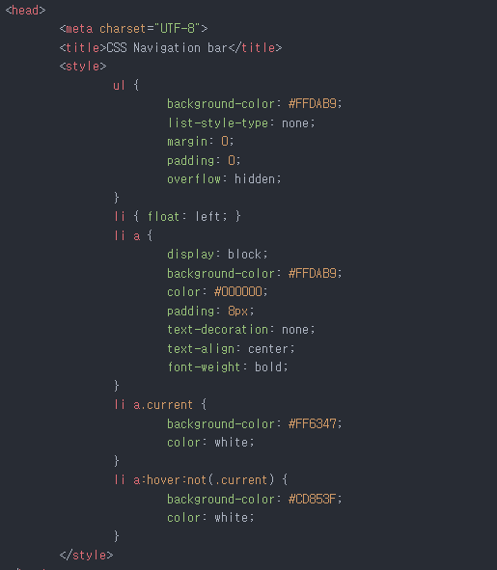

<head>

<meta charset="UTF-8"> <title>CSS Navigation bar</title> <style> ul {

background-color: #FFDAB9; list-style-type: none; margin: 0; padding: 0; overflow: hidden;

li { float: left; } li a {

display: block; background-color: #FFDAB9; color: #000000; padding: 8px; text-decoration: none; text-align: center; font-weight: bold;

Ti a.current

background-color: #FF6347; color: white;

Ti a:hover:not(.current) {

background-color: #CD853F; color: white;

</style>